AAP Database design

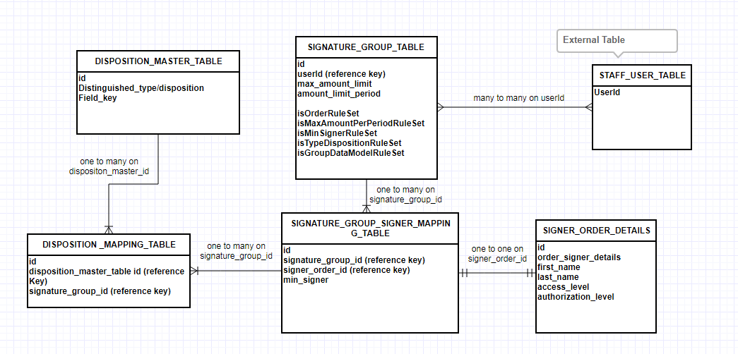

----------------------------------set of services based on requirement------------------------------------

**FUN_07 (By Minimum Signer)**

createGroup

deleteGroup

updateGroup (including add or remove user to group)

addMinSignersRule

removeMinSignerRule

updateMinSignerRule

returnListOfGroups (including minimum nuber of signers)

returnListOfSignerForGroup

**FUN_01 (By Signer order)**

addOrderToGroup

removeOrderFromGroup

updateOrderForGroup

getOrderForGroup

**FUN_03 (By Desposition type)**

addDespositionRule

removeDespositionRule

updateDespositionRule

isUserValid

**FUN_04 (By Amount limit)**

addAmountLimitation

removeAmountLimitation

updateAmountLimitation (including reset counter)

isUserValid

**FUN_06 (By data Group)**

createDataGroup // is it in out scope

removeDataGroup

updateDataGroup

addDataGroupToSignatureGroup

removeDataGroupfromSignatureGroup

updateDataGroupinSignatureGroup

isUserValid

Queries

How to store isSigned information on user level ?

Max amount limit will be set on user level or disposition level ?

FUN_06 clarity on how to apply rule ? we will get disposition type or field key from document ?

Is there any relation between FUN_03 and FUN_06 ?